1.1P: Preparing for OOP – Answer Sheet

1. Explain the following terminal instructions:
   1. cd: Access’ a directory
   2. ls: Lists files
   3. pwd: Writes your current directory’s address
2. Consider the following kinds of information, and suggest the most appropriate data type to store or represent each:

|  |  |
| --- | --- |
| Information | Suggested Data Type |
| A person’s name | String |
| A person’s age in years | INT |
| A phone number | String |
| A temperature in Celsius | INT |
| The average age of a group of people | Float |
| Whether a person has eaten lunch | Bool |

1. Aside from the examples already provided in question 2, come up with an example of information that could be stored as:

|  |  |
| --- | --- |
| Data type | Suggested Information |
| String | A Message to be written |
| Integer | Passengers on a Train |
| Float | Object Location data in a 2D or 3D Scene |
| Boolean | Whether someone enjoys swimming |

1. Fill out the last two columns of the following table, evaluating the value of each expression and identifying the data type the value is most likely to be:

|  |  |  |  |
| --- | --- | --- | --- |
| Expression | Given | Value | Data Type |
| 6 |  | 6 | INT |
| True |  | 1 | Bool |
| a | a = 2.5 | 2.5 | Float |
| 1 + 2 * 3 |  | 7 | INT |
| a and False | a = True | 1 (True) | Bool |
| a or False | a = True | 1 (True) | Bool |
| a + b | a = 1  b = 2 | 3 | INT |
| 2 * a | a = 3 | 3 (assuming a = 1 now) | INT |
| a * 2 + b | a = 2.5 b = 2 | 7 | INT |
| a + 2 * b | a = 2.5  b = 2 | 6.5 | Float |
| (a + b) * c | a = 1  b = 1  c = 5 | 10 | INT |
| “Fred” + “ Smith” |  | Fred Smith | String |
| a + “ Smith” | a = “Wilma” | Wilma Smith | String |

1. Using an example, explain the difference between **declaring** and **initialising** a variable.

The difference between the two is, declaring a variable begins with giving said variable a value which is used first

* String Msg = “Hello World”;

Vs an initiated variable is one which is simply declared in order to be edited later on.

* String Msg = “”;
* Msg = Console.Readline();

1. Explain the term **parameter**. Write some code that demonstrates a simple of use of a parameter. You should show a procedure or function that uses a parameter, and how you would call that procedure or function.

A parameter limits the size of a value, for example an age of only 18 allowed could be written as:

* int Age = 0;
* Age = Cosole.Readline();
* If (Age < 18) {//Code to Restart Program}

1. Using an example, describe the term **scope** as it is used in procedural programming (not in business or project management). Make sure you explain the different kinds of scope.

Scope is the accessibility of an element, for example a global variable can be accessed from anywhere within the program, whilst a local one can be accessed only within a function or class. In C# Variables are initialized at whatever level their use should be; Class, Function, ect

1. In a procedural style, in any language you like, write a function called Average, which accepts an array of integers and returns the average of those integers. Do not use any libraries for calculating the average. You must demonstrate appropriate use of parameters, returning and assigning values, and use of a loop. Note — just write the function at this point, we’ll *use* it in the next task. You shouldn’t have a complete program or even code that outputs anything yet at the end of this question.

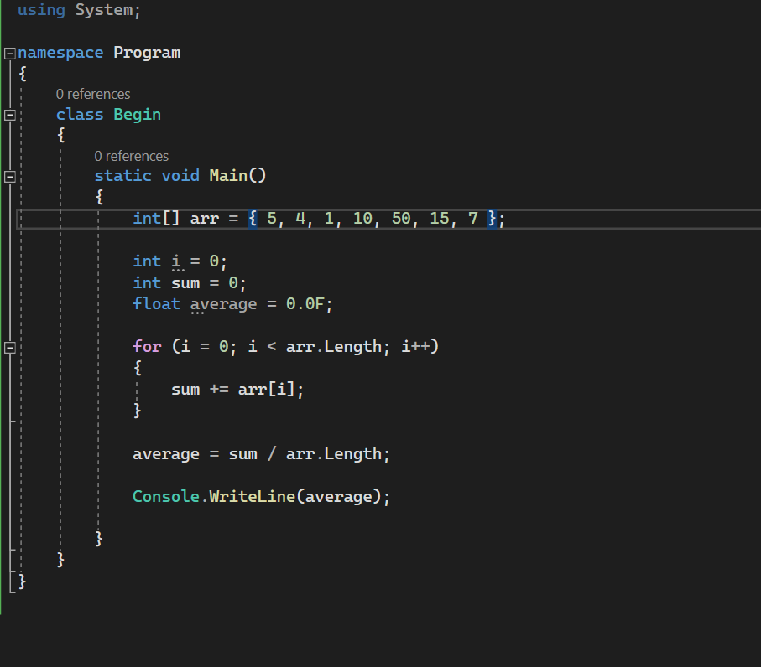

1. In the same language, write the code you would need to call that function and print out the result.

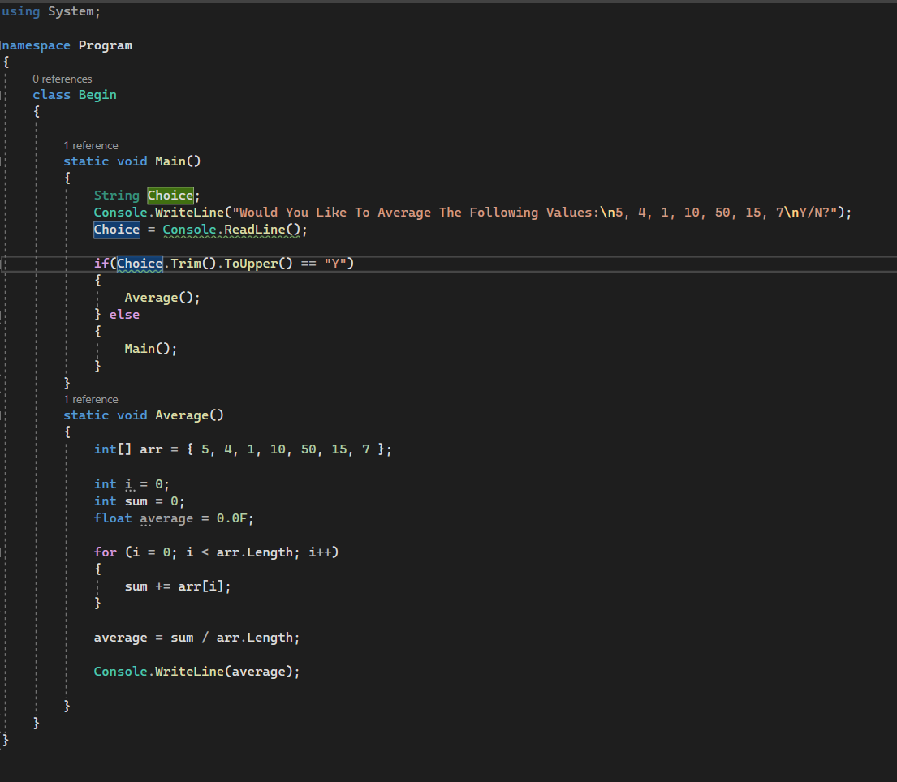

1. To the code from 9, add code to print the message “Double digits” if the average is above or equal to 10. Otherwise, print the message “Single digits”. Provide a screenshot of your program running.



